

Course T1Y2: Advanced Algorithms

Lecturer: Bou Channa

Student’s name: Chea Ilong

ID: 100022

Group: 1 SE Gen10

Lab 4: Assignment

Exercise1:

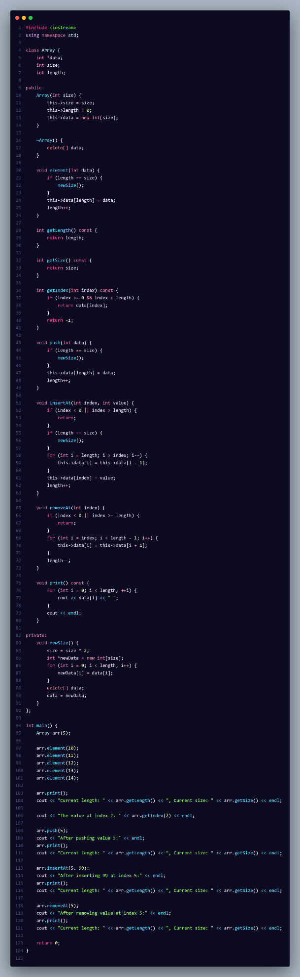

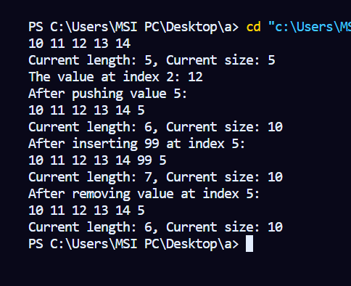

Exercise2:

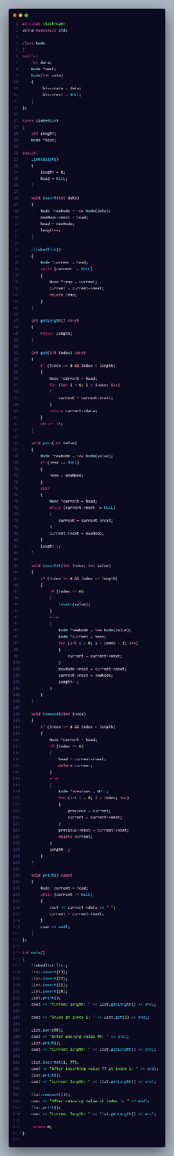

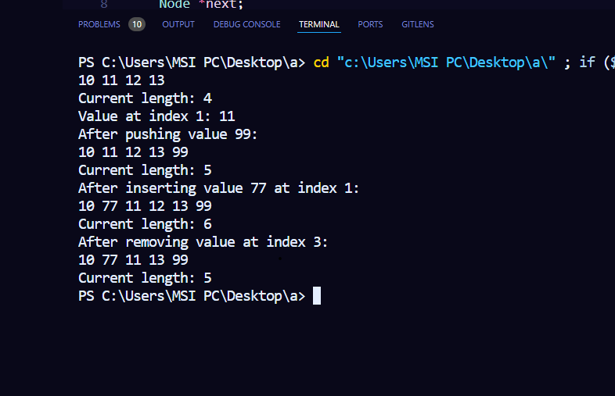

Exercise3:

1. Analyze the **key limitations** of arrays and single linked lists regarding some **specific cases**:

* Identify use cases where limitations can appear
* Compare the performances of the 2 data structures regarding each use case

*Examples of use cases:*

* *Going backward (from the end to the beginning of the list)*
* *Inserting a value in the middle of the list*
* *Deleting a value at the beginning*
* *Sorting a list of numbers.*
* *…*

1. Present your **analysis results** using a table:

|  |  |  |
| --- | --- | --- |
|  | ARRAY | LINKED LIST |
| *Use case 1* | Not perform | Perform |
| *Use case 2* | Not perform | Not perform |
| *Use case 3* | Not perform | Perform |
| Etc… | Perform | Not perform |

1. **Explain your results** in terms of time/space **complexity**.

**Array**:

* Time Complexity:

Accessing one element: O(1).

Insert and Remove: O(n) it require us to shift the elements;

* Space Complexity: Fixed size;

**Linked List**:

* Time Complexity:

Accessing an element: O(n).

Insertt and remove: O(1) (

* Space Complexity: Dynamic size,

1. Identify 3 Real-World Scenarios. For each scenario, describe which structure is the most suitable

*Examples of real scenarios:*

* *A music player where you need to go to the previous song.*
* *A round-robin scheduling system that loops through tasks continuously.*

|  |  |  |
| --- | --- | --- |
| Real-World Scenario | Most Appropriate Data Structure | Reason |
| Storing and sorting exam scores | Array | Fixed, static list of scores with efficient sorting and access. |
| Storing a fixed list of employees in an organization | Array | Fixed size, constant-time access to employee data using indices. |
| Music player’s history of recently played songs | Linked List | Dynamic tracking of recently played songs with easy addition/removal of songs. |